1. hadoop fs -copyFromLocal C:\BigData\hadoop-2.9.1\etc\hadoop\abc.txt /assignment

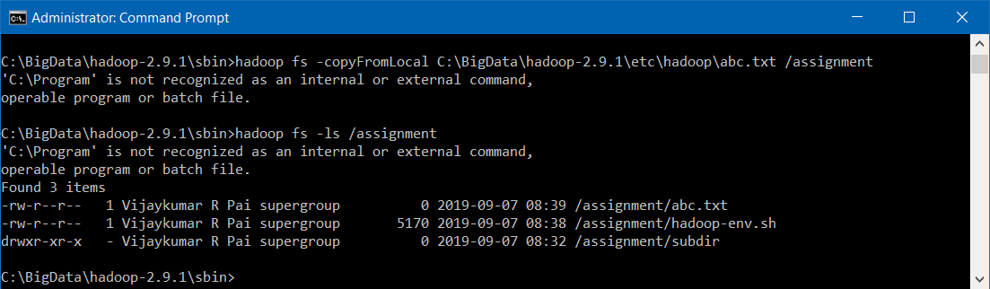

1. hadoop fs -ls -h /assignment

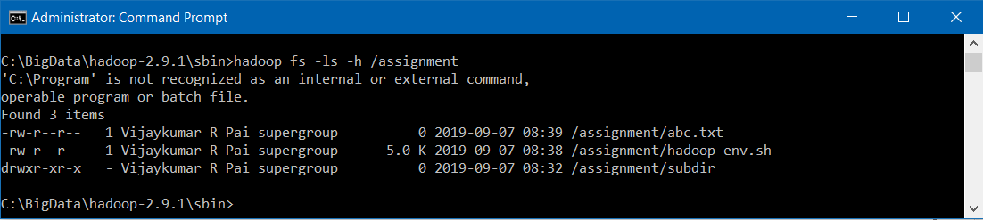

1. hadoop fs -mkdir /assignment/tr1/

hadoop fs -mkdir /assignment/tr1/tr2

hadoop fs -mkdir /assignment/tr1/tr2/tr3

1. hadoop fs -put C:\BigData\hadoop-2.9.1\etc\hadoop\sample.txt /assignment/tr3

hadoop fs -put C:\BigData\hadoop-2.9.1\etc\hadoop\sample.txt /assignment/tr2

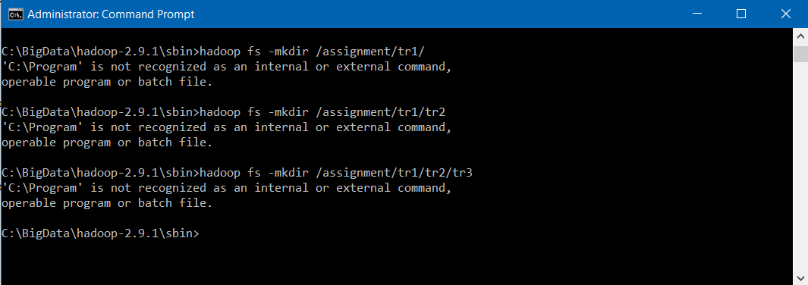

1. hadoop fs -appendToFile - /tr3/sample.txt

hadoop fs -cat /tr3/sample.txt

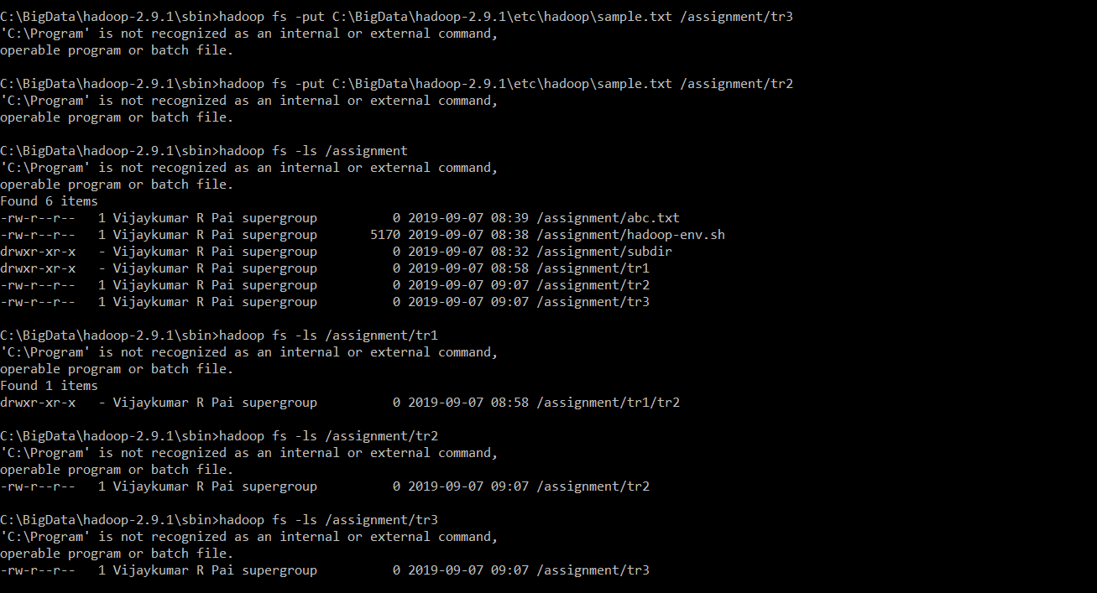

1. hadoop fs -mv /tr3/sample.txt /tr1

hadoop fs -ls /tr1

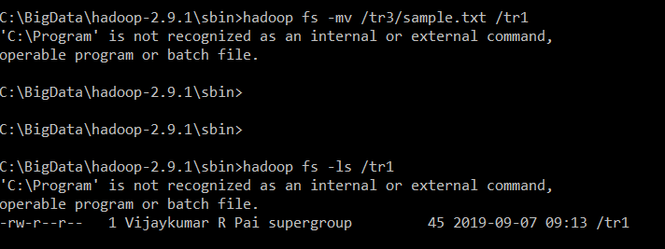

1. hadoop fs -get /tr3/sample.txt C:\BigData\hadoop-2.9.1\etc\hadoop\sample.txt



1. hadoop fs -ls -r -S /assignment

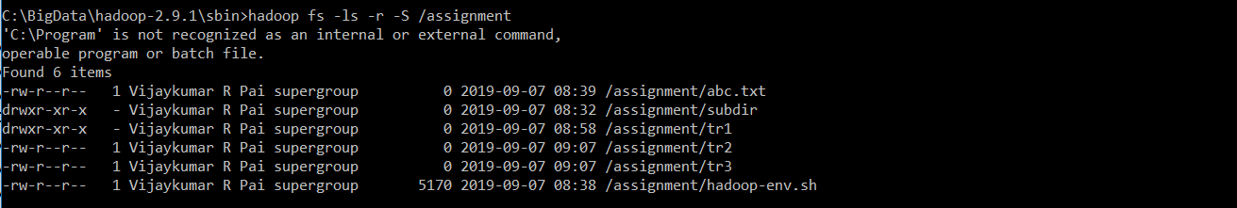

1. hadoop fs -mkdir /newtest

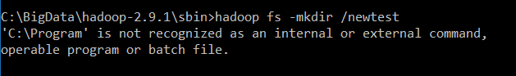

1. hadoop fs -touchz /assignment/tr1/newSample.txt

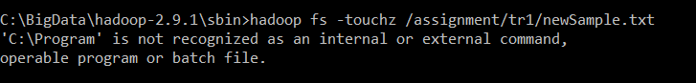

1. hadoop fs -copyFromLocal C:\BigData\hadoop-2.9.1\etc\hadoop\bcd.txt /assignment/tr1

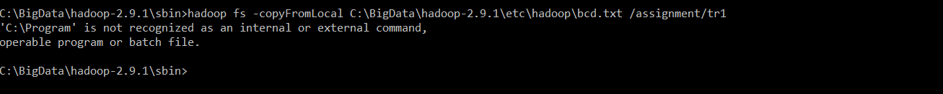

1. hadoop fs -get /assignment/tr1 /newtest

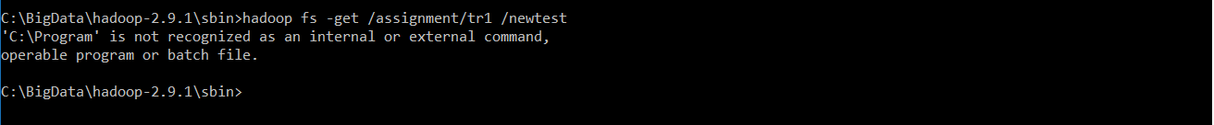

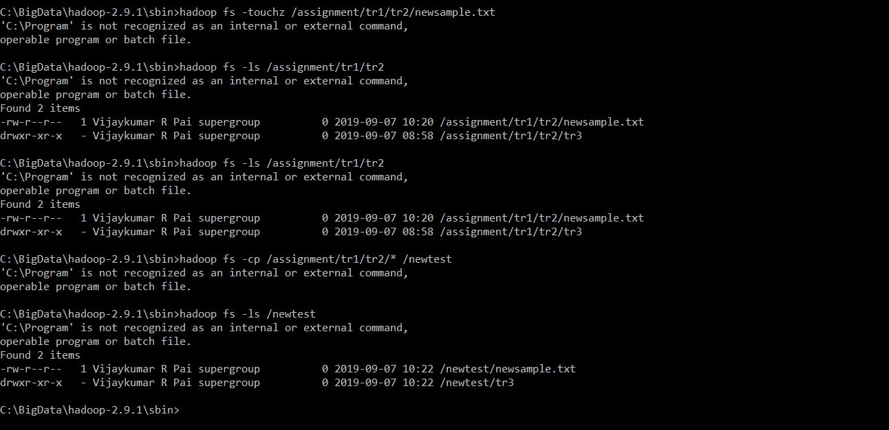

1. hadoop fs -ls -t /newtest



1. 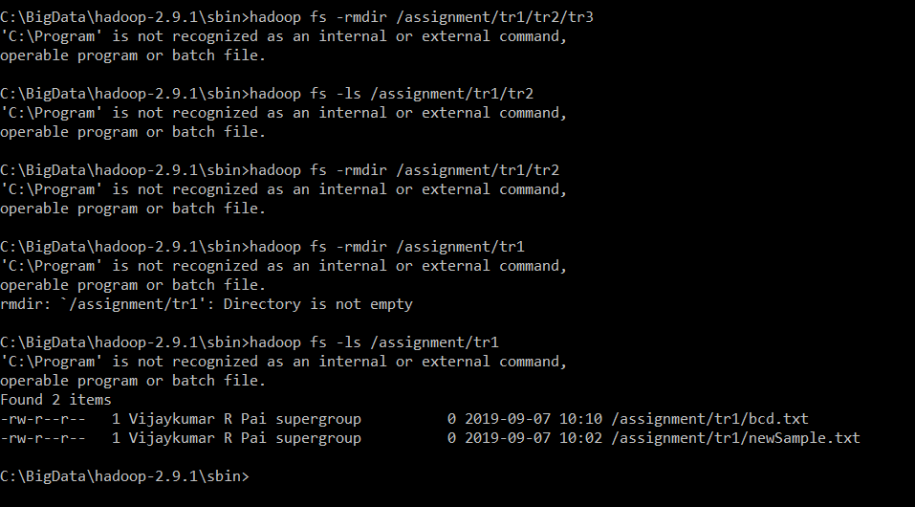

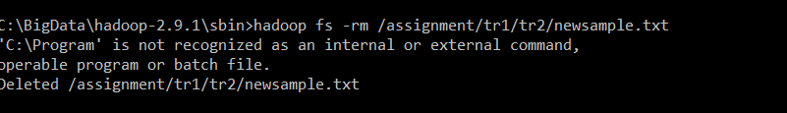

1. hadoop fs -usage setfacl

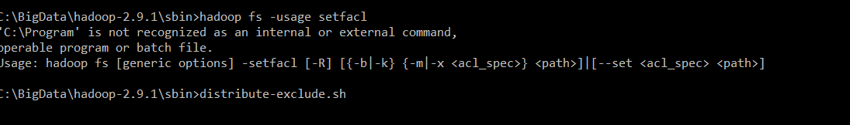

1. hadoop fs -truncate 5 /assignment/Sample.txt

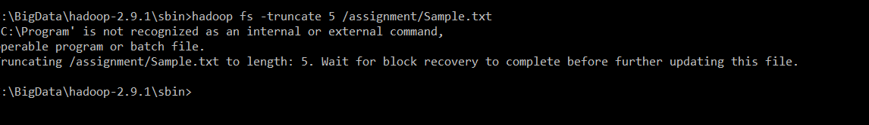

1. hadoop fs -tail /assignment/abc.txt



1. dwda

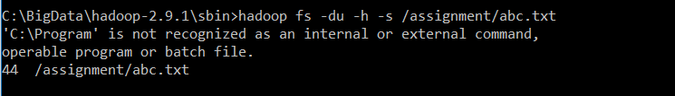

1. hadoop fs -df -h /newtest

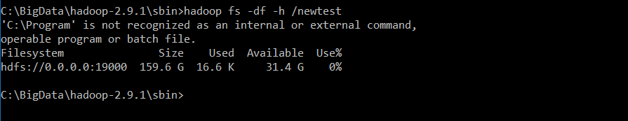

1. hadoop fs -count -q -h -v /assignment

